National College of Computer Studies
Paknajol, Kathmandu

Lab Report
On
Information Security

Submitted by: Submitted to:
Name: Siddhartha Shakya Radha Krishna Gajurel
Program: BIM
Roll no: 18
Section: B

National College of Computer Studies
Paknajol, Kathmandu

Lab Report
On
Artificial Intelligence

Submitted by: Submitted to:
Name: Siddhartha Shakya Er.Khushbu Kumari Sarraf
Program: BIM
Roll no: 18
Section: B

S.N. | Program Title | Submission Date | Signature | Remarks

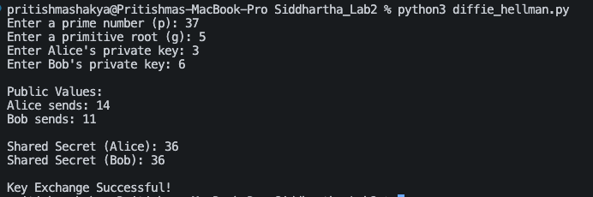
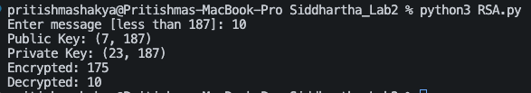
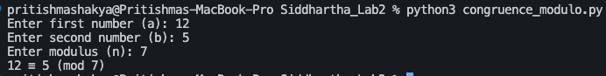

National College of Computer Studies
Paknajol, Kathmandu

Lab Report No. 1
Software Design and Development

Submitted by: Submitted to:
Name: Siddhartha Shakya Kabita Dhital
Program: BIM
Roll no: 18
Section: B

Date of submission: 2026/02/23

National College of Computer Studies
Paknajol, Kathmandu

Lab Report No. 2
Software Design and Development

Submitted by: Submitted to:
Name: Siddhartha Shakya Kabita Dhital
Program: BIM
Roll no: 18
Section: B

Date of submission: 2026/02/23

National College of Computer Studies
Paknajol, Kathmandu

Lab Report No. 3
Programming with Python

Submitted by: Submitted to:
Name: Siddhartha Shakya Sumit Ghising
Program: BIM
Roll no: 18
Section: B

Date of submission: 2026/02/05

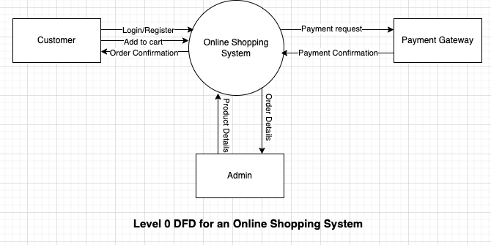
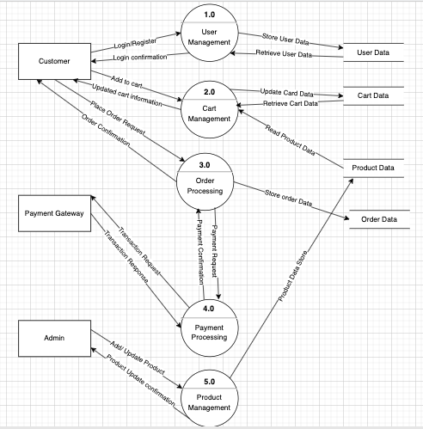
Level 1 DFD for an online Shopping System

